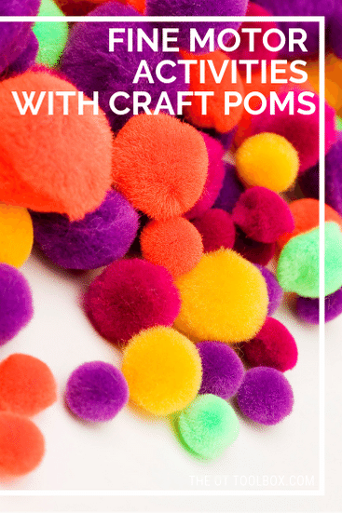

KIDS NEED MORE FINE MOTOR ACTIVITIES
You may have heard stories about how kids are lacking in fine motor skills more and more. THere are several reasons for this problem. It’s very concerning! Kids have less outdoor time and more scheduled activities, allowing for less free-play. Kids need fine motor skills for school and play. When fine motor skills are impaired, there may be challenges with pencil grasp, functional tasks like scissor use, clothing fasteners, and tasks like manipulating materials.

EASY FINE MOTOR ACTIVITIES WITH CRAFT POM POMS
Adding more fine motor activities into a child’s day can be a struggle. So having an easy list ready to go makes recommending fine motor activities a no-brainer. Use these activity ideas in fine motor home programs or in the classroom for fine motor centers. Adding them to math centers would be easy…craft pom poms are fun to sort, count, and manipulate!

WHY USE CRAFT POM POMS IN FINE MOTOR ACTIVITIES?
Craft pom poms are so versatile! There’s a reason why every OT has them in their therapy bag of tricks! Craft pom poms are a great way to work on various fine motor skills including:
Separation of the sides of the hand– Pom poms make a great item to hold in the palm while encouraging movement and precision with the pointer finger, middle finger, and thumb.
Pincer grasp– Craft pom poms make a powerful means of promoting the precision grasp between the thumb and pointer finger.
In-hand manipulation– Craft pom poms can be used as a manipulative item for transfering from the palm to the finger tips or vice versa. This is an essential skill needed in pencil grasp.
Finger isolation– Craft pom poms can be used in various ways to promote finger isolation needed for fine motor dexterity and functional tasks.
Eye-hand coordination– This skills is an essential fine motor precision skill needed for so many functional tasks. Craft pom poms can be a powerful way to work on this skill area.

CRAFT POM POM ACTIVITIES
Here is a big list of activity ideas for using craft pom poms to work on fine motor skills. What would you add to this list? To start, here are more fine motor activities that use craft pom poms. Using this craft item in fine motor development requires easy set-up with activities like the ones listed below. You’ll see using a water bottle to work on fine motor skills in the list. Here’s a better description of how to make that craft pom pom fine motor activity work.
- Drop craft pom poms into an empty water bottle
- Use tweezers to place craft pom poms into an ice cube tray
- Pinch them with tongs or tweezers
- Pinch them with clothes pins
- Poke toothpicks into craft pom poms
- Pound a golf tee into a craft pom pom, using a hammer and a cardboard box
- Press them onto double sided tape
- Squeeze craft pom poms with color coded fingers. Use color-coded hair bands to mark fingers
- Hide them in the palm of the hand and drop into color coded spice containers
- Fill containers by sorting the pom poms by color
- Create a color by number picture with craft pom poms
- Press them into paint and dot paint by squeezing and swiping pom poms onto paper
- Place a certain number of pom poms onto number cards or playing cards
- Fill number puzzle by placing pom poms into the open spaces one-by-one
- Use craft pom poms to form numbers and letters
- Press them onto contact paper
- Create texture mazes with clear packing tape
- Create a fine motor ninja course using craft pom poms to hop fingers over and around
- Make a Simon game board by using craft pom poms to form “buttons”
- Make crafts! This fine motor craft is just one idea.
- Create a twister board for fingers using the craft pom poms for color spots

