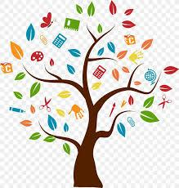
More Practical Life Skills

- Gain a new leisure activity (card game, IPad game, craft, etc)
- Cut coupons from the newspaper or mail inserts
- Find the barcode on boxed/canned food items. Pretend the first three numbers is the cost and count out that amount of money to pay. = $1.23
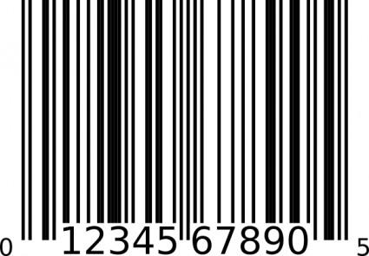

- Transcribe the paragraph of a book into a typed report on phone or IPad notes keyboard
- Take out all silverware from tray in the drawer, clean the drawer, then reset all of the silverware
- Cut up an old shirt or jacket so that it is shaped like a “bib” to fit overhead and hand down the front and master buttoning and zipping.
- Sort the laundry in the basket into whites and colors
- Practice finding “911” on a fake device or IPad
- Learn a joke

