Occupational Therapy Activities-Summer

Choose 1-2 items from each category and complete 1-2x per week
Warm Up:
- Beach Towel Boogie: Have the child choose a beach towel and place on the floor. Start some music and your child moves around the room but as soon as music stops, they have to get back to sit on their beach towel.
- Hopscotch
- Beach Ball Game: Make cards or a spinner of different activities to do with your child: Catch, Kick, Roll, bounce, and throw.
- 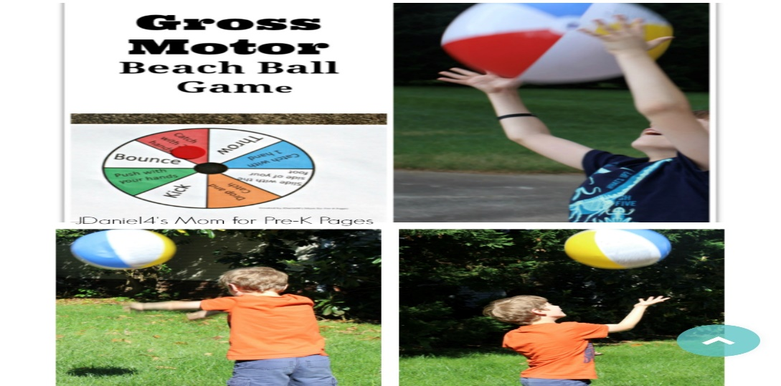

Sensory:
- Sand sensory box: Get sand or colored sand (dollar tree) and add shells, funnel, small colorful cups, pony beads and fun scoopers.
- Bumble Bee Fidget: Supplies you need: yellow balloon, funnel, flour and sharpie marker.
- 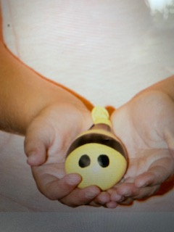

Fine Motor:
- Sun Painting Craft: Supplies you need: paper, paints (red, yellow, orange) plastic wrap and paint brush. First cut out a circle (you or your child can do) Next add a little of each paint to circle, then place plastic wrap over paint and let child squish paint onto circle. Next remove the plastic wrap and glue sun onto another piece of paper and have you child paint lines for sun rays.
- 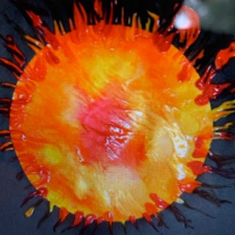
- Rainbow Necklace: Have your student string colorful beads on string/yarn to make necklaces or bracelets. For older children can work on patterns.
- 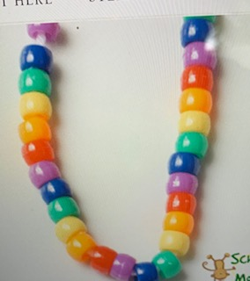
- Ice cream Cone build: Cut out small triangles (ice cream cones) and write numbers on the cones then have your child place the corresponding number of pom poms onto the cone. To make it more difficult you can use tweezers or kitchen tongs.
- 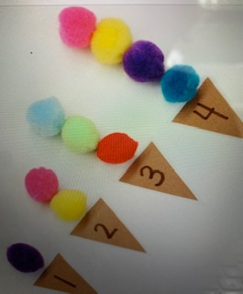
- Clothes Pin Sun: Take a paper plate and have your child color it yellow like the sun then have them add clothes pins around the edges for rays. Can make it more academic by adding numbers/letters, or shapes
- 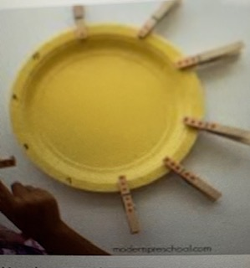
Visual Motor:
- Pool Noodle Puzzles: Draw items on the pool noodle with a sharpie then cut in pieces and have students put them together.
- 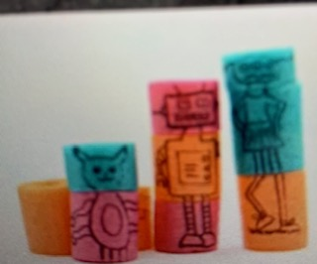
- Build a boat: Have student cut out simple shapes (circles, triangles, rectangle and half circle) and then use it to build a boat like this example. (Some students may need assist with cutting)
- 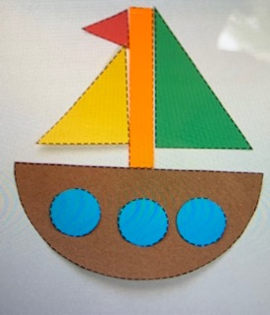
- Paint with Ice: Supplies you need: Ice tray, 1 cup of water, food coloring (red, yellow and blue) and popsicle sticks. Have student work on making lines, shapes, letters or their name.
- 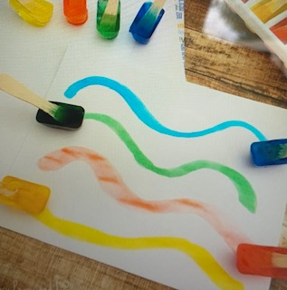

Life Skills:
- Have your child help set the table for dinner
- Have Child put their dirty clothes in laundry basket or hamper
- Have child dress self for the day

Oculomotor:
- Go to www.eyecanlearn.com and do the “tracking link” (PK-3)
- Beach ball game: Write letter, numbers or shapes on beach ball with a sharpie. Have your child catch the ball and yell out what the item is they see on the ball.
Cool Down:
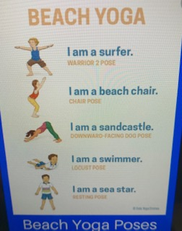

I miss everyone and hope your guys have a great summer.
Ms. Katie

