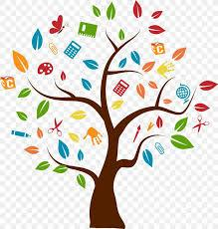
Practical Life Skills
- Find correct change in a coin purse for a vending machine purchase
- Take care of any pets’ feeding, watering and play/exercise for one week
- Find and circle every letter of the alphabet in a magazine or newspaper article
- Help prepare a boxed desert doing as many of the instructions independently as you can
- Set the table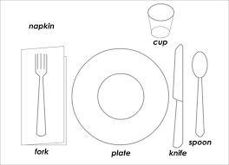
- sort all the money in a wallet into ones, fives, tens and twenties, facing in the same direction.
- Order independently at a fast food restaurant using a tech device, speech or pointing at menu choices
- Put laundry on hangers
- Ball/matching socks together
- Put together outfits for one week, laying all items out the night prior
- Dust all surfaces in any room
- Wipe down all kitchen surfaces
- Vacuum 2 rooms
- Sweep the kitchen
- Load the dishwasher
- Practice measuring and pouring ¼ cup, ½ cup, ¾ cup and 1 cup of water
- Get a grocery list from an adult of 3 items and locate them in the store using signs or item cues in the isles
- Go on a walk or drive and locate a stop sign, a yield sign and each color stoplight
- Practice your legal signature
- Do all steps of oral hygiene independently (brush, rinse, floss)

